Chapter 3
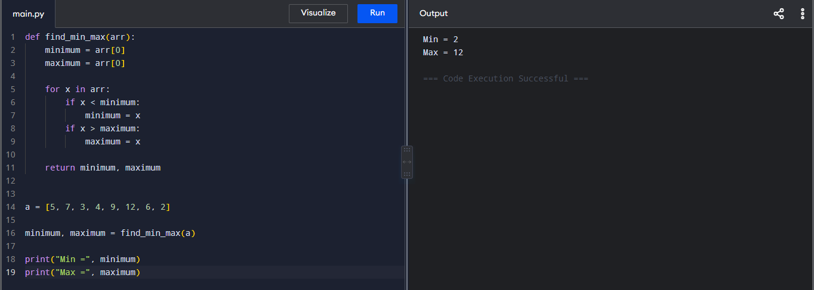
- Maximum and Minimum in an Array

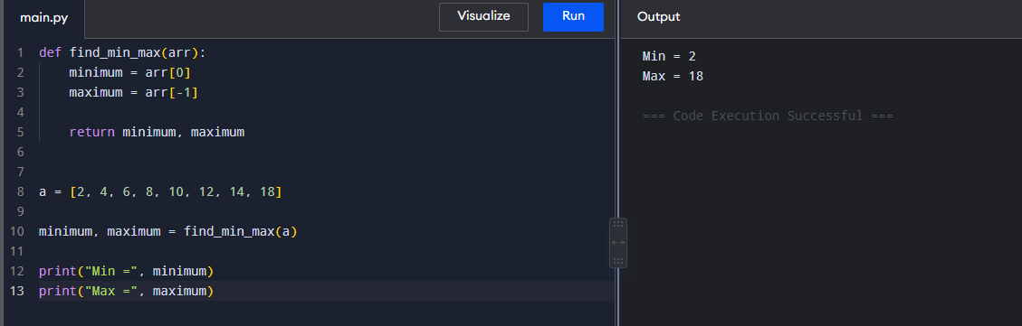
- Maximum and Minimum in a Sorted Array

- Merge Sort
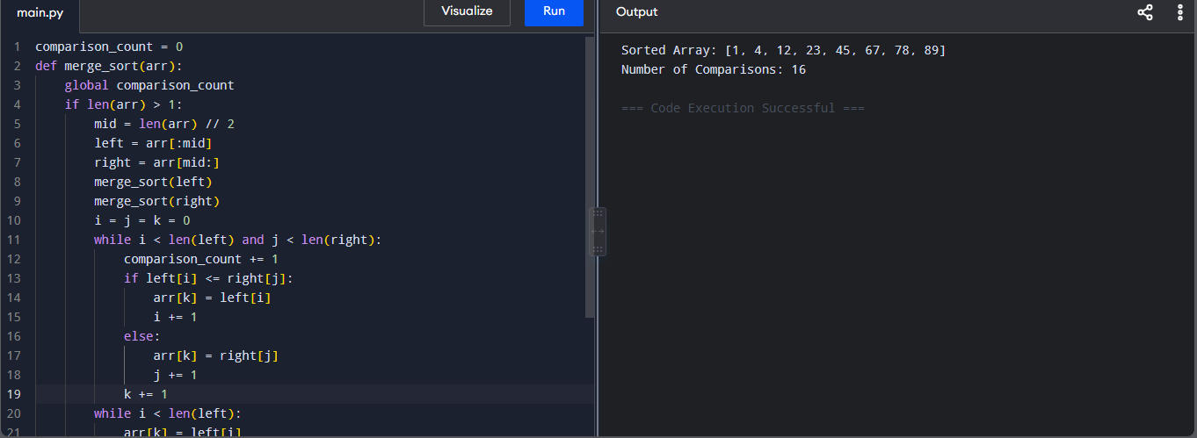
- Merge Sort with Comparison Count
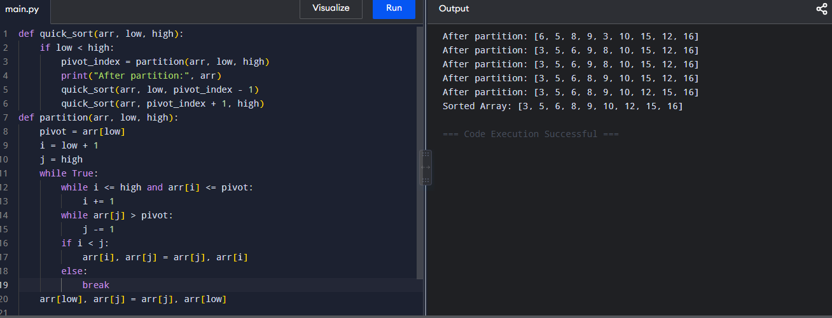
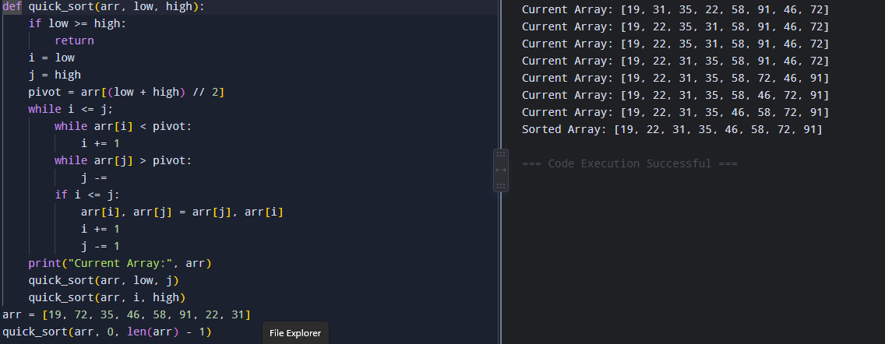
- Quick Sort Using First Element as Pivot

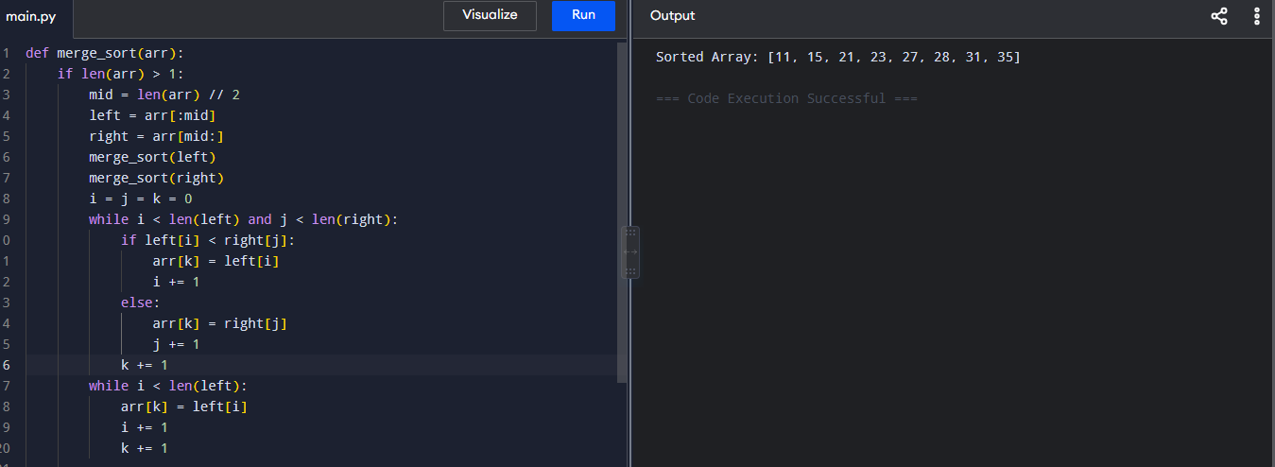
- Quick Sort Using Middle Element as Pivot

- Binary Search with Comparison Count

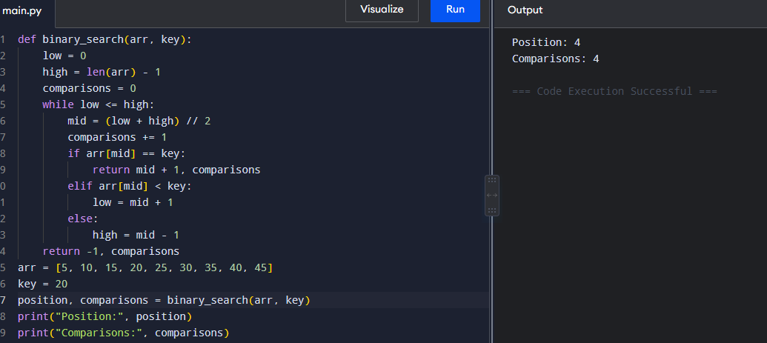

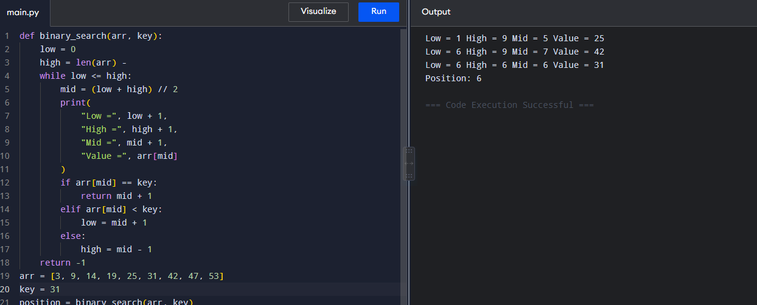
- Binary Search with Mid-Point Calculations

- K Closest Points to the Origin
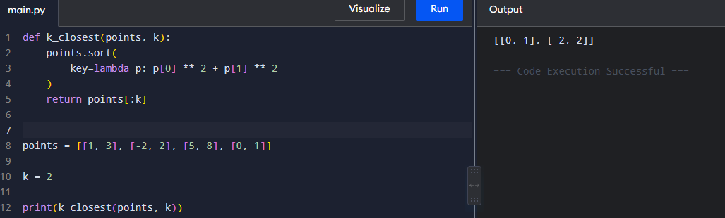
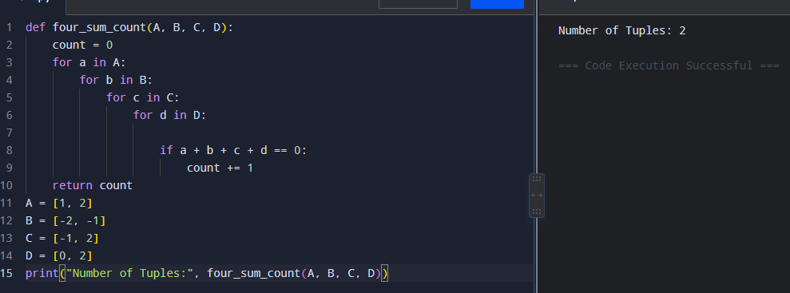
- Four Sum Count

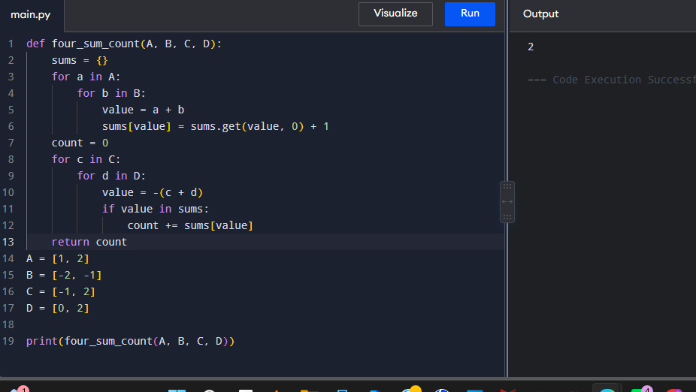

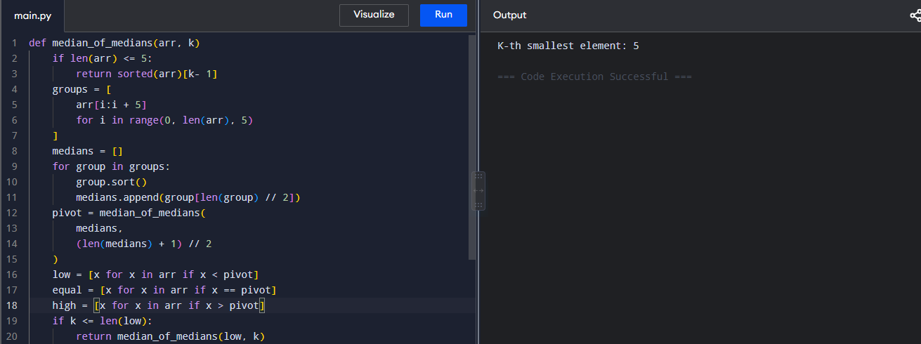
- Median of Medians Algorithm

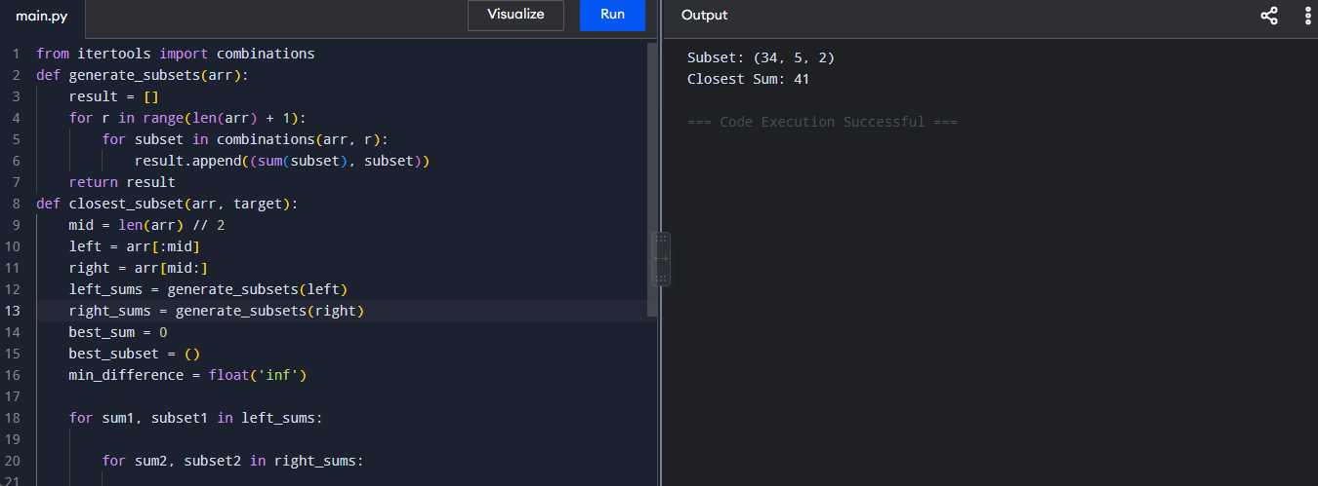
- K-th Smallest Element Using Median of Medians

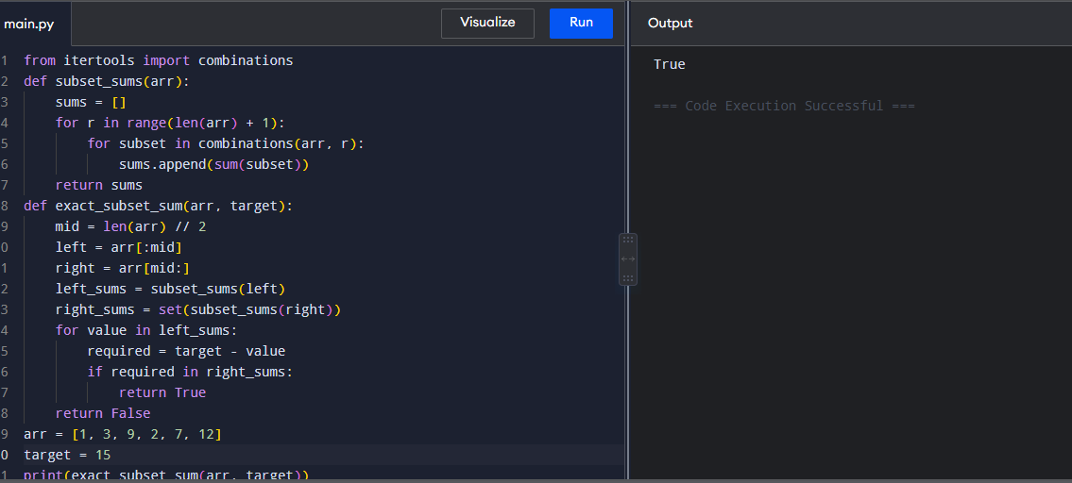
- Meet in the Middle – Closest Subset Sum

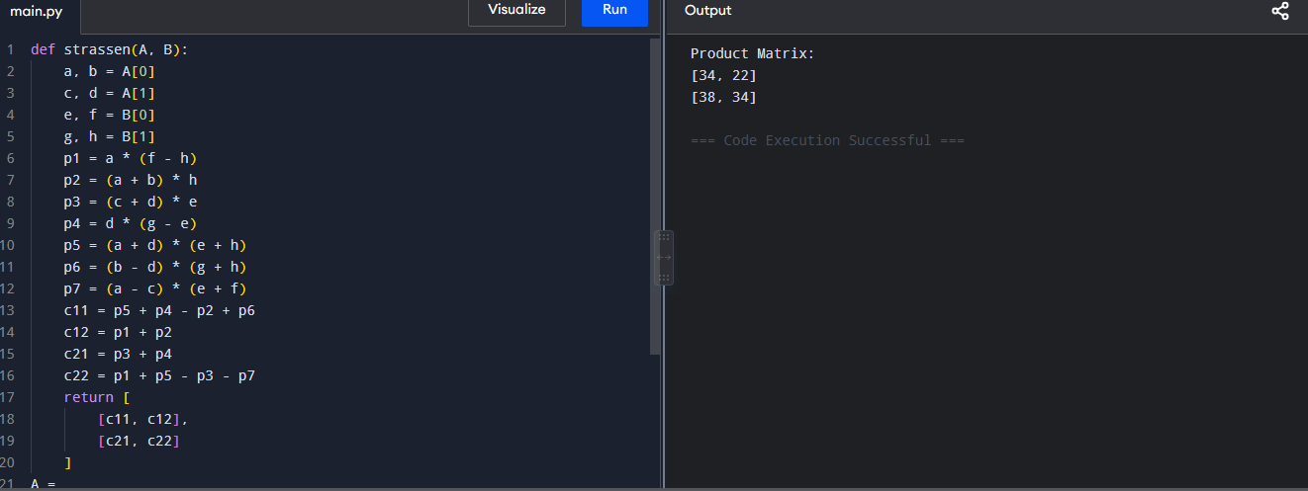
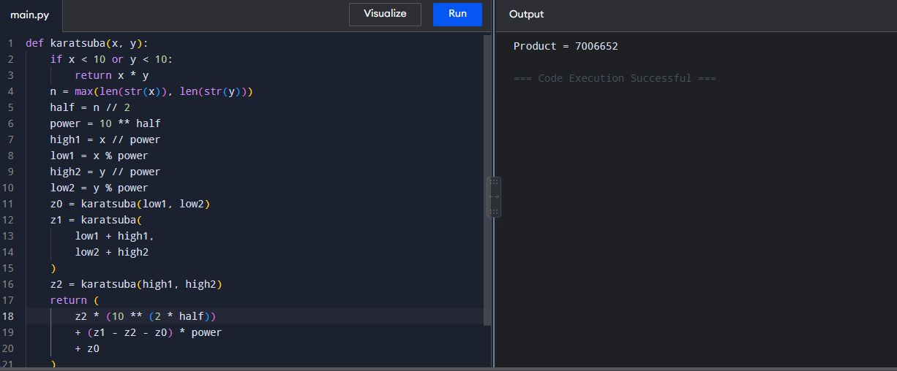
- Meet in the Middle – Exact Subset Sum

- Strassen’s Matrix Multiplication

